System Study

1.Online Shopping System Project in Python Django

The main purpose of this project is to build a platform where the buyers and sellers can connect with each other online. These kinds of projects or websites are used to sell products and gain some money out of it.

Project Prerequisites and Features

**Prerequisites to develop Online Shopping System in Django**:

Html, Css, JavaScript, Bootstrap, Python Django.

**Features**:

* User Authentication (register and login)
* Session of each user is saved using cookies.
* All Products with their view, key features and reviews by other users.
* Users are able to search for any product.
* Cart Functionality.
* Proper Order Summary Before Placing Order.
* Change Password Facility.
* Contact Us.

**2.Online Shopping Project In Python**

* The objective of the online shopping site project is to provide assistance in buying and selling of goods and services online. This Online shopping project is developed in python django, so Students who are looking for a python project can also consider this project because we provide source code along with the project so that they can learn and gain experience in real time projects.
* **Features for Consumers/ Users**
  + Category by products.
  + Find classified products.
  + Add products in the cart.
  + See orders placed by you.
  + See products in the cart.
  + Can select mode of payment.
  + Can add billing address.
  + Can register themselves on the website.

* **Features for Admin**
  + Secure login process.
  + Can add products with their images, prices etc.
  + Can add category and subcategory of the product.

3.Python Shop Management System Project

Shop management is an application that helps in managing the products and tracking the sales in the shop.

We will build this project using the Tkinter and MySQL Connector modules in Python. We use the MySQL Connector to store the details in a table and access them. Using this we will build GUI where the user gets to do the following:

1. Add a product
2. Delete a product
3. View all products
4. Generate a bill and store it in a database

**4.Django E-commerce Web Application**

**Scope**: The scope of the project will be limited to some functions of the e-commerce website. It will display products, and customers can select catalogs and select products and can remove products from their cart specifying the quantity of each item. Selected items will be collected in a cart. At checkout, the item on the card will be presented as an order. Customers can pay for the items in the cart to complete an order. This project has a great future scope. The project also provides security with the use of login ID and passwords, so that no unauthorized users can access your account. The only authorized person who has the appropriate access authority can access the software.

**ER Diagram for E-commerce Website**

**Customer Interface**

1. Customer shops for a product
2. Customer changes quantity
3. The customer adds an item to the cart
4. Customer views cart
5. Customer checks out
6. Customer sends order

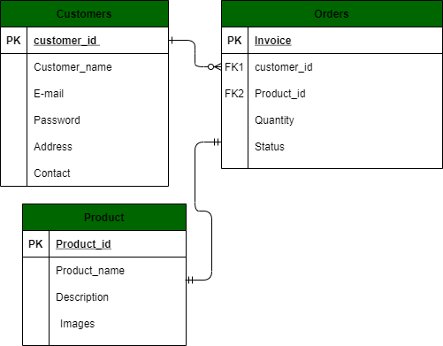

*ER-diagram for Customer*

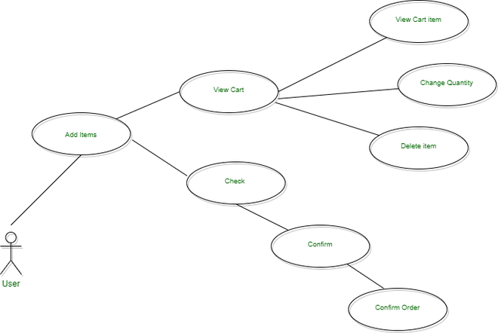

*Use-Case diagram for Customer*

**Admin Interface**

1. [Admin](https://www.geeksforgeeks.org/python-django-admin-interface/) logs in
2. Admin inserts item
3. Admin removes item
4. Admin modifies item